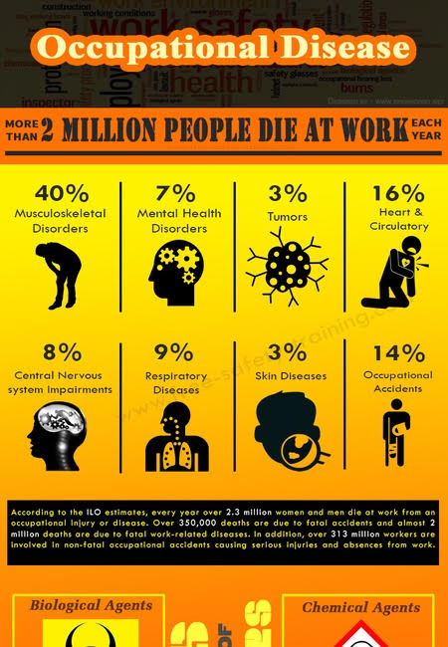

“Saudi Arabia’s Vision 2030” encompasses—in a number of domains—strategic objectives, targets, outcome-oriented indicators, and commitments that are to be achieved by the public, private, and non-profit sectors. In relation to control of occupational diseases and related events, how this goals could be achieved? And what are the evidence base that you could illustrate to explain such goals in the country?
Instruction for developing the assignment report
The report should include the following topics as section headings.
1-Background: this section should clearly describe the background of the assigned issue (e.g. a brief history of the nature/purpose of the issue globally and locally),
2-Situation in Riyadh or KSA: past and current situation of this issue in Riyadh or KSA (e.g. its introduction or implementation, levels, any incidents).this the part I need it to be done.
3-Environmental/public health relevance: a clear and scientific description of diseases or health effects potentially associated with the issue, how it causes/contributes to the disease or how it increases public health risks.
4-Methods for assessing and preventing environmental risks: with a focus on the situation here in Saudi Arabia. Describe how risks can be assessed (e.g. determination of exposure levels, exposure routes, population at risk). Based on the literature suggests methods of managing the risk and preventing/reducing exposure.
5-Conclusions and Recommendations: your input of what can be done to improve the situation and prevent or reduce health risks related to the issue.
6-References: For any piece of scientific information, cite the reference (mainly journal article or book, in some cases reports from Ministry or organization) used to retrieve the information. Number references in the order they appear in the text. The reference list should come after the main text (not included in the total page requirement).
Format and style
-Double space text using font size of 12. Use clear scientific English. The report may contain 2000 (+/-10%) excluding references, figures and tables.

Assignment report:

- Background
“My primary goal is to be an exemplary and leading nation in all aspects, and I will work with you in achieving this endeavor... “
Custodian of the Two Holy Mosques
King Salman Bin Abdulaziz Al-Saud

Firstly, the main themes of Vision 2030:
- Vibrant society
- Thriving economy
- Ambitious nation

In order to achieve these themes, many programs have been established, such as Quality of life program, Housing program, Financial sector development, National transformation program…, etc.

Quality of Life program is the most related program to our topic, because it improves individuals’ lifestyles by developing an ecosystem to support and create new options that boost citizens’ and residents’ participation in cultural, environment, and sports activities. This is in addition to other suitable activities that contribute to enhancing the quality of life of individuals and families, creating jobs, diversifying economic activity, and raising the status of Saudi Arabian cities so that they rank among the best cities in the world (1).
Examples of the objectives that are reflect what we work on: Offer a fulfilling & healthy life, by Improving healthcare service, Promote a healthy lifestyle and Strengthen prevention against health threats. Also, Ensure environmental sustainability by reduce all types of pollution, such as air, water, soil,… (2)
Occupational diseases:
Firstly, we’re going to talk more about The Occupational Health and the diseases that may occur. The term “Occupational Health” refers to the science that is concerned with preserving safety and health of a person during his work. It is done by providing the appropriate and safe environment that is free from any causes of accidents, injuries, or occupational diseases. So, the concept of occupational health can be defined as a set of rules and procedures, established within a legislative framework with the aim of protecting human and property related to a specific profession.
Moreover the occupational diseases, it is a disease that affects an individual, as a result of the nature of his work or professional activity. Also, it is defined when it spread in a specific work environment compared to the general population environment, or another work environment.
The injury can be caused by exposure to various factors which may be chemical, physical, biological, carcinogenic or radioactive, unlike a work injury that is usually caused by a one-time accident. An occupational disease is usually a result of permanent and repeated exposure witch cause damages over time.
Examples,
* Coal worker's pneumoconiosis, from inhaling too much coal dust working in a coal mine.
* Hearing loss, from not wearing adequate ear protection in occupations with loud noises.
* Rabies, by working around wild animals.

History and numbers:
In 1948, a universal declaration of Human Rights was issue, and adopted by the United Nations General Assembly. That declaration stats that all people have the right to have just and favorable conditions of work. Unfortunately, there are hundreds of millions of people in the world working under unfair or unfavorable conditions.
According to the World Health Organization, workers got 250 million accidents annually, death cases are up to 330,000, economical losses equal 4% of global gross national product. All that without to mentioning damages that caused by the dispersal of families and societies (3)
In Saudi Arabia:
In the Kingdom of Saudi Arabia, the ministry of Labor is the agency responsible for laws related to occupational health. The Ministry issued the Occupational Safety and Health regulations, which sets binding laws to all operating agencies in Saudi Arabia. All its details can be found on the website of the Saudi Ministry of Labor, and it is constantly updated (4)

Ref:
- https://vision2030.gov.sa/en/programs/QoL
- https://vision2030.gov.sa/sites/default/files/vision/Vision%20Realization%20Programs%20Overview.pdf
- https://www.who.int/news-room/fact-sheets/detail/protecting-workers'-health
- https://mlsd.gov.sa/ar/photo-album/219031

- Situation issues in SA, specifically in Riyadh
- Environmental/Public Health relevance
Environmental/public health relevance
Occupational Health and Vision 2030:
“We will improve the business environment, so that our economy grows and flourishes, driving healthier employment opportunities for citizens and long-term prosperity for all.”(OSHAS) https://oshas.org.sa/about/8
Occupational and work-related diseases:
As per the World Health Organization: an occupational disease is resulted primarily of exposure to risk factors related to work activity, where factors in the work environment may play a role with other risk factors in the development of such diseases. Major occupational factors that cause public health risks: such as injuries, airborne exposures, carcinogens, ergonomic stressors, noise and other specific risks. (WHO). https://www.who.int/occupational_health/activities/occupational_work_diseases/en/ There are four types of occupational hazards: chemical, biological, physical, and psychosocial.
International Labor Organization list of occupational diseases includes but not limited to:
- Occupational diseases caused by exposure to agents (chemical, physical, biological) arising from work activities
- Occupational diseases by target organ systems (Respiratory diseases, Skin diseases, Musculoskeletal disorders, Mental and behavioral disorders)
- Occupational cancer caused by different agents.
(ILO)
https://www.ilo.org/wcmsp5/groups/public/@ed_protect/@protrav/@safework/documents/publication/wcms_125137.pdf

“The World Day for Safety and Health at Work is an annual international campaign to promote safe, healthy and decent work. It is held on 28 April and has been observed by the International Labour Organization (ILO) since 2003” (United Nations) (https://www.un.org/en/events/safeworkday/)
According to the World Health Organization, occupational health is linked with the public health and the development of health system. Including: occupational environment’s risk of diseases and injuries, social and individual factors, and the accessibility to health services. (Who) https://www.who.int/health-topics/occupational-health

The Ministry of Human Recourses and Social Development has an occupational safety and health policy “OSH” that works “Towards Attractive Work Environment”. OSH, aims to promote and protect the health of all employees and visitors in related to the workplace environment. Another goal is to preserve the work site properties and environments in relevance to the occupational risks including accidents and occupational diseases. (MISD)
https://mlsd.gov.sa/sites/default/files/1%29%20%D9%86%D9%85%D8%A7%D8%B0%D8%AC%20%D9%84%D8%A7%D8%A6%D8%AD%D8%A9%20%D8%A7%D8%AF%D8%A7%D8%B1%D8%A9%20%D8%A7%D9%84%D8%B3%D9%84%D8%A7%D9%85%D8%A9%20%D9%88%D8%A7%D9%84%D8%B5%D8%AD%D8%A9%20%D8%A7%D9%84%D9%85%D9%87%D9%86%D9%8A%D8%A9_%D8%A7%D9%84%D9%85%D8%B3%D8%AA%D9%88%D9%89%20%D8%A7%D9%84%D8%A7%D8%AF%D9%86%D9%89.pdf
Occupational Safety and Health consideration in the workplace are important public health issues that the employees’ attention should be drawn to. In order to improve the occupational health and workplace environment by increasing efficiency & productivity in addition to reduce staff turnover and occupational absence there are several essential steps to achieve the workplace safety including: raising the awareness of OSH concepts and procedures in the workplace, providing practical guidance and direction to employers on methods to improve OSH in the workplace and contributing in enhancing OSH culture in the Kingdom of Saudi Arabia. (MISD) https://mlsd.gov.sa/sites/default/files/Implementation%20of%20Risk%20Management_0.pdf

OSH Risk Management Cycle:
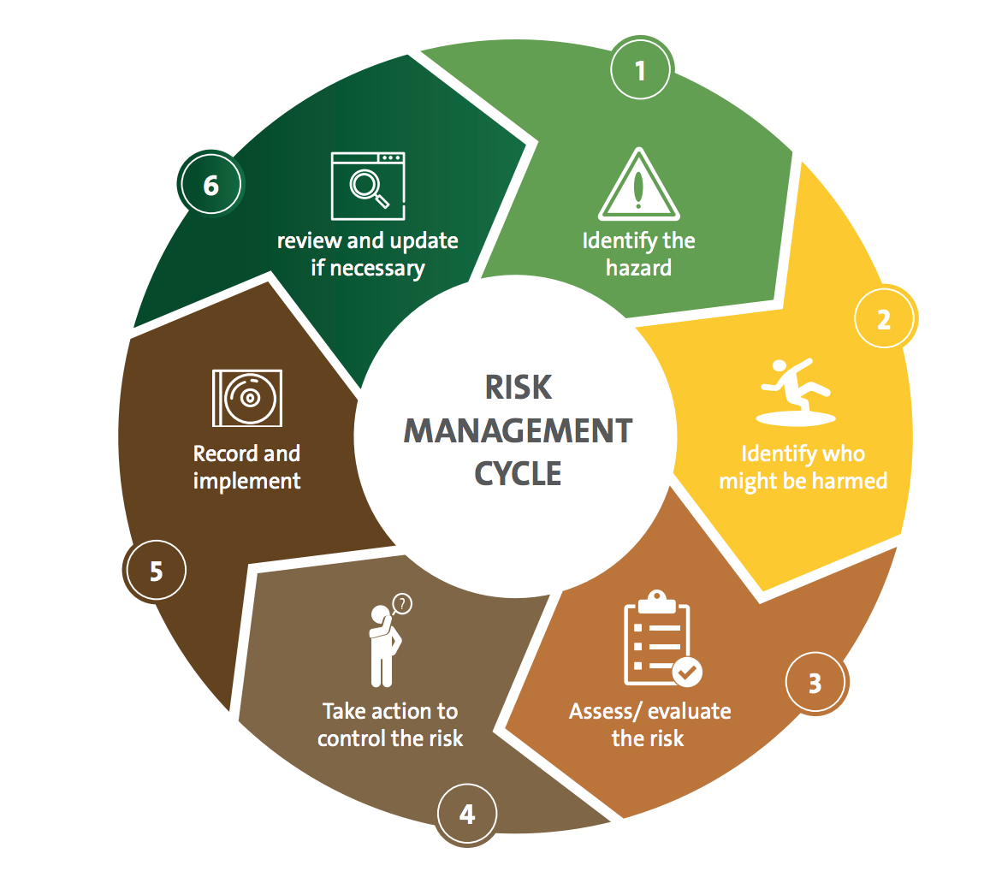
“OSHAS”, The Association of Occupational Safety and Health and Civil Guards is a “specialized association working to raise the level of participation between the different sectors by harmonizing initiatives with common objectives, as one of sustainable development social responsibility tools and one of national volunteerism pillars in Saudi Arabia within 2030 Vision” (OSHAS). (https://oshas.org.sa/about/1)

References:
- https://oshas.org.sa/about/8
- https://www.who.int/occupational_health/activities/occupational_work_diseases/en/
- https://www.ilo.org/wcmsp5/groups/public/@ed_protect/@protrav/@safework/documents/publication/wcms_125137.pdf
- https://www.un.org/en/events/safeworkday/
- https://www.who.int/health-topics/occupational-health
- https://mlsd.gov.sa/sites/default/files/1%29%20%D9%86%D9%85%D8%A7%D8%B0%D8%AC%20%D9%84%D8%A7%D8%A6%D8%AD%D8%A9%20%D8%A7%D8%AF%D8%A7%D8%B1%D8%A9%20%D8%A7%D9%84%D8%B3%D9%84%D8%A7%D9%85%D8%A9%20%D9%88%D8%A7%D9%84%D8%B5%D8%AD%D8%A9%20%D8%A7%D9%84%D9%85%D9%87%D9%86%D9%8A%D8%A9_%D8%A7%D9%84%D9%85%D8%B3%D8%AA%D9%88%D9%89%20%D8%A7%D9%84%D8%A7%D8%AF%D9%86%D9%89.pdf
- https://mlsd.gov.sa/sites/default/files/Implementation%20of%20Risk%20Management_0.pdf
- https://oshas.org.sa/about/1

- Methods of assessing and preventing environmental
- Conclusion and recommendations
- References

- http://eprints.nottingham.ac.uk/39206/1/Firefighters%20JTSDT-5-164%20PTSD%20Saudi%20firefighters%202016.pdf
- https://www.researchgate.net/publication/11343365_Occupational_health_in_Saudi_Arabia
- https://ejhm.journals.ekb.eg/article_11879_0c7838be652f472da922eba9d5a3357f.pdf
- https://www.researchgate.net/publication/329744924_Trends_in_occupational_injuries_and_diseases_among_Saudi_and_non-Saudi_insured_workers
- https://www.researchgate.net/publication/11343365_Occupational_health_in_Saudi_Arabia

B. Situation issues in SA, specifically in Riyadh

